Natural Disaster Intensity Analysis and Classification using Artificial Intelligence

**PROJECT REPORT**

**Submitted by**

**Team ID:PNT2022TMI43250**

**S. MANOJ (715319104016)**

**V. ARAVINDH (715319104001)**

**S. MANIKANDAN (715319104015)**

**M. JOTHIRAJ (715319104010)**

**In partial fulfilment for the**

**award of the degree of**

**BACHELOR OF ENGINEERING**

**In**

**COMPUTER SCIENCE AND ENGINEERING**



**ASIAN COLLEGE OF ENGINEERING AND TECHNOLOGY**

**COIMBATORE - 641110.**

TABLE OF CONTENTS

1. INTRODUCTION 4
   1. Project Overview 4
   2. Purpose 5
2. LITERATURE SURVEY 5
   1. Existing problem 5
   2. References 6
   3. Problem Statement Definition 7
3. IDEATION & PROPOSED SOLUTION 8
   1. Empathy Map Canvas 8
   2. Ideation & Brainstorming 9
   3. Proposed Solution 10
   4. Problem Solution fit 11
4. REQUIREMENT ANALYSIS 11
   1. Functional requirement 11
   2. Non-Functional requirements 12
5. PROJECT DESIGN 13
   1. Data Flow Diagrams 13
   2. Solution & Technical Architecture 14
   3. User Stories 17
6. PROJECT PLANNING & SCHEDULING 19
   1. Sprint Planning & Estimation 19
   2. Sprint Delivery Schedule 20
   3. Reports from JIRA 21
7. CODING & SOLUTIONING 21
   1. Feature 1 21
   2. Feature 2 21
8. TESTING 22
   1. Test Cases 22
   2. User Acceptance Testing 23
9. RESULTS 24
   1. Performance Metrics 24
10. ADVANTAGES & DISADVANTAGES 25
11. CONCLUSION 26
12. FUTURE SCOPE 27
13. APPENDIX 28

Source Code 28

GitHub & Project Demo Link 48

Natural Disasters Intensity Analysis and Classification Using Artificial Intelligence

1. INTRODUCTION :

1.1 Project Overview:

Natural Disasters are catastrophic events with atmospheric and historic origins (hurricanes, floods, tsunamis, earthquakes). That can cause fatalities, property damage and social environment disruption.

Natural disasters are the results of a hazard overwhelming highly vulnerable community, often resulting in mortality and morbidity. Over the past decade, over 300 natural disasters occur yearly around the world affecting millions and cost billions. The disaster cycle is a framework used to base a coordinated plan to respond, recover, prevent, and prepare for a disaster. Access to clean water, proper sanitation, /nutrition, shelter, and the threat of communicable diseases are concerns that have potential to be detrimental to the management of a natural disaster, slowing the recovery process.

Natural disasters not only disturb the human ecological system but also destroy the properties and critical infrastructures of human societies and even lead to permanent change in the ecosystem. Disaster can be caused by naturally occurring events such as earthquakes, cyclones, floods, and wildfires. Many deep learning techniques have been applied by various researchers to detect and classify natural disasters to overcome losses in ecosystems, but detection of natural disasters still faces issues due to the complex and imbalanced structures of images. To tackle this problem, we developed a multi layered deep convolutional neural network model that classifies the natural disaster and tells the intensity of disaster of natural The model uses an integrated webcam to capture the video frame and the video frame is compared with the Pre-trained model and the type of disaster is identified and showcased on the Open CV window

1.2 Purpose:

Basically the main objective of natural disaster management is to reduce the damage. However, there are several objectives that are integrated with it. Those are,

1.Identifying the hazard and its cause.

2. Reducing vulnerability and potential losses of hazard.

3. Assessing, reviewing and controlling the risk.

4. Applying efficient, effective, sustainable relief (food, shelter and money), medical and other facilities in disaster affected people thus they can survive.

5. Reducing the damage, death, sufferings and destruction of any natural and human induced disaster.

6. Giving protection to victims

7. Increasing the strength among people to survive against disasters.

8. Building up capacity in every sector like- individual, social, economic, environmental, regional, national and international.

9. Ensuring the availability of local emergency equipment and transportation.

10.  Promote the culture of disaster risk prevention and mitigation at all levels.

2. LITERATURE SURVEY:

2.1 Existing problem:

Natural disasters not only disturb the human ecological system but also destroy the properties and critical infrastructures of human societies and even lead to permanent change in the ecosystem.

Disaster can be caused by naturally occurring events such as earthquakes, cyclones, floods, and wildfires. Many deep learning techniques have been applied by various researchers to detect and classify natural disasters to overcome losses in ecosystems, but detection of natural disasters still faces issues due to the complex and imbalanced structures of images.

2.2 References:

1. “Number of reported disasters by type.” [Online]. Available: [https://ourworldindata.org/natural-](https://ourworldindata.org/natural-disasters) [disasters.](https://ourworldindata.org/natural-disasters)
2. Watusi and T. Hashish, “Disaster Prevention Education in Rapier Volcano Area Primary Schools: Focusing on Students’ Perception and Teachers’ Performance,” Proceed Environment. Sci., vol. 20, pp. 668– 677, 2014.
3. “2015_43291_Sendaiframeworkfordrren_Disaster Reduction2015-2030,” 2015.
4. S. Goswami, S. Chakraborty, S. Ghosh , A. Chakrabarti, and B. Chakraborty, “A review on application of data mining techniques to combat natural disasters,” Ain Shams Eng. J., vol. 9, no. 3, pp. 365–378, 2018.

1. I. A. T. Hashed, I. Yaobang, N. B. Annular, S. Mortar A. Gain, and S. Allah Khan, “The rise of ‘big data’ on cloud computing: Reviewed open research issues,” Inf. Cyst., vol. 47, pp. 98–115,2015.

1. M. Yu, C. Yang, and Y. Li, “Big Data in Natural Disaster Management: A Review,” Geo sciences, vol. 8, no. 5, p. 165, 2018.
2. P. Sciences, “science direct,” 2018. [Online]. Available: https://[www.sciencedirect.com/.](http://www.sciencedirect.com/)

1. Springer, “innerspring,” Technology, 2018. [Online]. Available: [https://www.springeropen.com/journals.](https://www.springeropen.com/journals)

1. IEEE, “IEEE,” 2018. [Online]. Available: [http://ieeexplore.ieee.org](http://ieeexplore.ieee.org/).
2. Google Scholar, “Google Scholar,” 2018. [Online]. Available: <https://scholar.google.com/intl/en/scholar/about.html>

2.3 Problem Statement Definition:

The purpose of the problem statement is to identify the issue that is a concern and focus it in a way that allows it to be studied in a systematic way. It defines the problem and proposes a way to research a solution, or demonstrates why further information is needed for a solution to become possible.

|  |  |  |  |  |  |
| --- | --- | --- | --- | --- | --- |
| **Problem Statement (PS)** | **Iam (Customer)** | **I’m trying to** | **But** | **Because** | **Which makes me feel** |
| PS-1 | An | Classify the | It is | The data is | Tensed and frustrated |
|  | employee  from NDRF | type of  natural disaster | difficult  to  identify | of images  and  images are of |  |
|  |  |  |  | various |  |
|  |  |  |  | forms |  |
| PS-2 | A student | classify the | It is | The data is | Tensed and frustrated |
|  |  | type of | difficult | of images |  |
|  |  | natural  disaster in order to learn about that disaster | to  identify | and  images are of various forms |  |

3. IDEATION & PROPOSED SOLUTION:

3.1 Empathy Map Canvas:

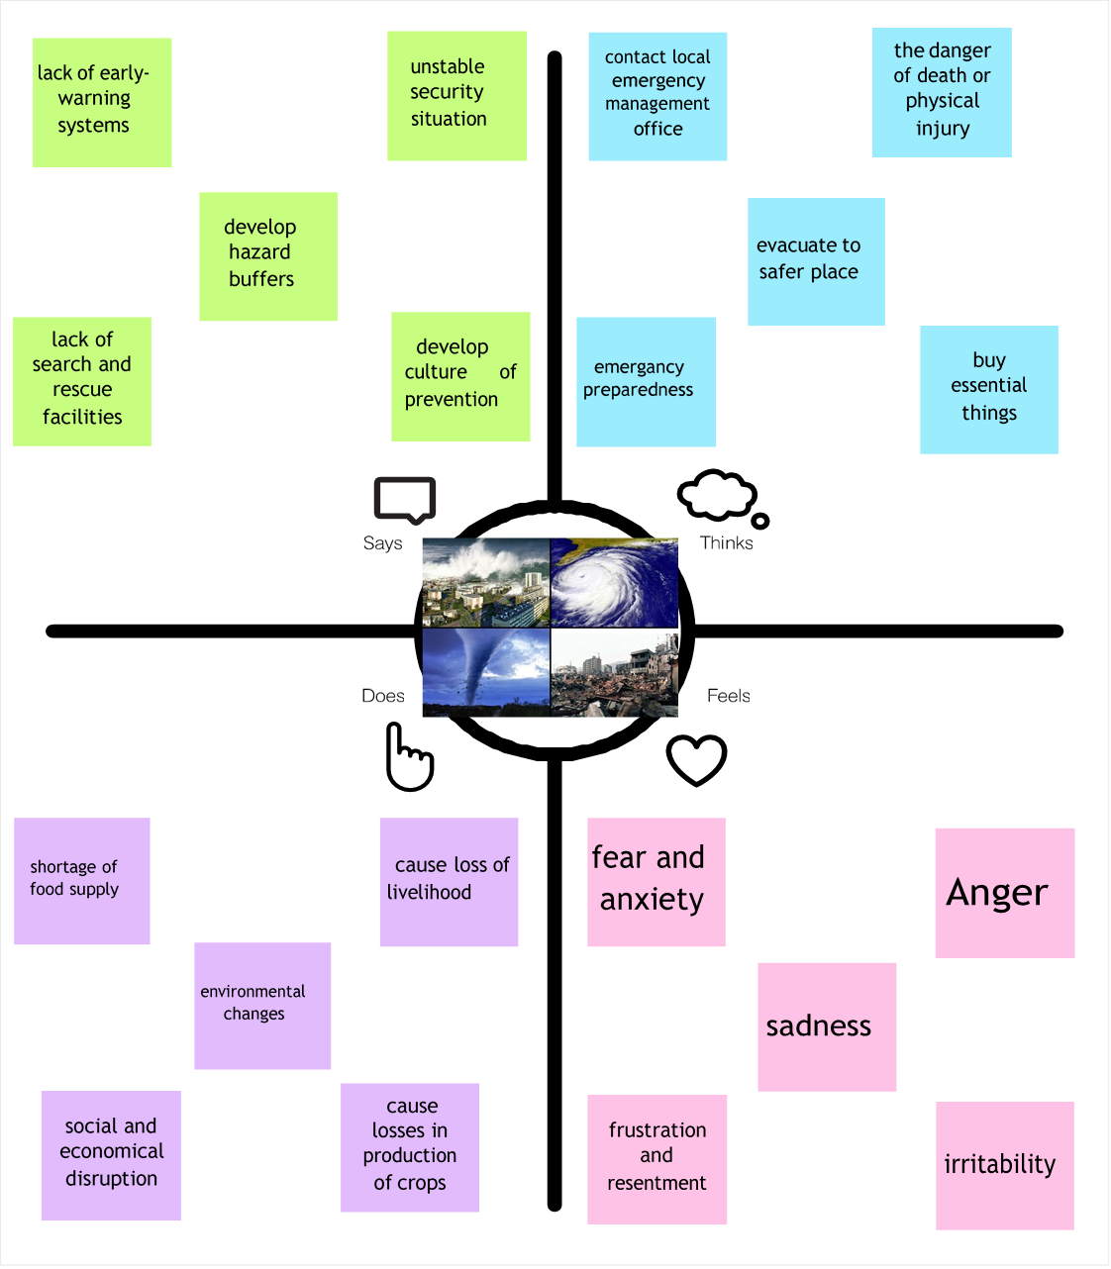

3.2 Ideation & Brainstorming:

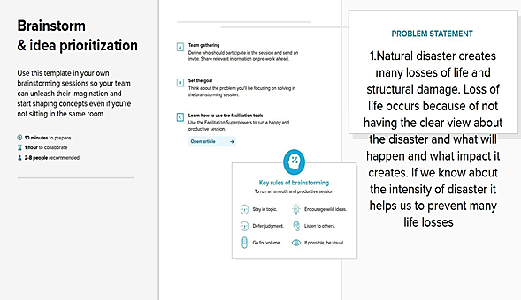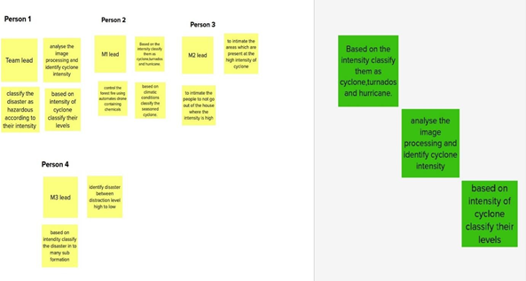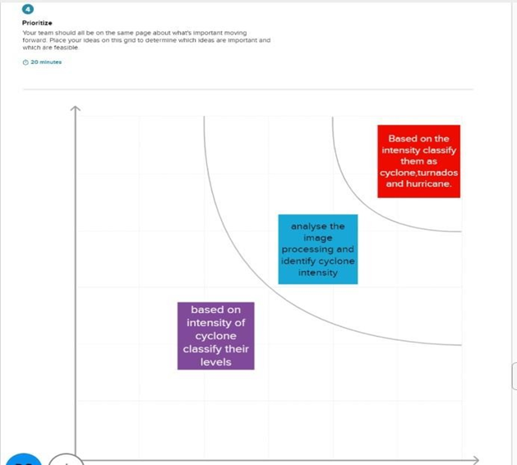

**Cyclone intensity evaluation:**

An application of state-of-art revolutionize method can be developed for prediction of wind-intensity for tropical cyclones in the South Pacific region. The method employed data from cyclone wind-intensity taken for the last three decades. This employs Cooperative Co evolution method for training Elm an recurrent neural networks for the prediction

**Flood intensity evaluation:**

A hybrid deep learning based flood forecasting can be developed. This approach has been made use of daily lagged IF and precipitation time series data to determine flood situations at multiple forecast horizons. The practicality of the model can be tested using datasets from nine locations in Fiji.

**Storm intensity evaluation:**

A storm scale ensemble post-processing system based on ensemble machine learning algorithms, radar mosaic verification, and ensemble variable statistics can provide improved precipitation forecasts.

Multiple machine learning models of varying complexity were applied to forecasts. Probabilistic, deterministic, and interval forecasts of 1-hour precipitation accumulation were created with the different models. Verification statistics showed that random forests, multiple logistic regression, and MARS provided significant improvements for probabilistic and continuous forecasts by both increasing the range of precipitation and probabilistic values predicted and by increasing the areal coverage of the precipitation forecasts

3.3 Proposed Solution:

|  |  |  |
| --- | --- | --- |
| **S.No.** | **Parameter** | **Description** |
| • | Problem Statement (Problem to be  solved) | To keep track of, foresee, and assess disasters  and their severity as they affect the area |
| • | Idea / Solution description | House classification algorithm to identify the  impacts of disaster |
| • | Novelty / Uniqueness | Usage of reinforcement learning algorithm to let the AI to be independent and capable of collecting necessary data for prediction on its  own. |
| • | Social Impact / Customer Satisfaction | This program me will both increase general knowledge of the effects of disasters and assist in making critical decisions in emergency  situations |
| • | Business Model(Revenue Model) | Revenue generated through Royalty payments, product license costs in department , research  and educational platforms |
| • | Scalability of the Solution | Disintegration of geographical terrains into  multiple provinces which can be interconnected as a grid to help alleviate its scale. |

3.4 Proposed Solution fit:

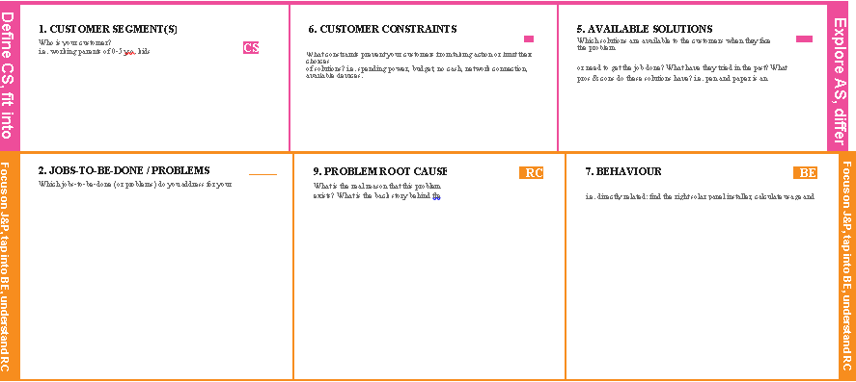

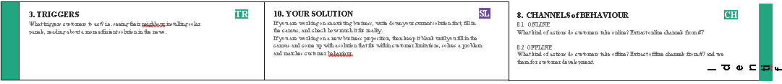

##### 

4. REQUIREMENT ANALYSIS:

4.1 Functional requirement:

Following are the functional requirements of the proposed solution

|  |  |  |
| --- | --- | --- |
| **FR No.** | **Functional Requirement (Epic)** | **Sub Requirement (Story / Sub-Task)** |
| FR-1 | User Registration | Registration through Form  Registration throughGmail  Registration through LinkedIN |

|  |  |  |
| --- | --- | --- |
| FR-2 | User Confirmation | Confirmation via  EmailConfirmation via OTP |
| FR-3 | Accuracy | Training and testing data fed to the model must be accurate to provide correct results. |
| FR-4 | Speed | The generation of the predicted results must be faster in order to take the necessary actions. |
| FR-5 | Resolution | The resolution of the integrated web camera should be high enough to capture the video frames in order to feed it to the model as inputs. |
| FR-5 | User Interface | Maximizing the uptime of the Web App Service. |

4.2 Non-functional Requirements:

Following are the non-functional requirements of the proposed solution.

|  |  |  |
| --- | --- | --- |
| **FR No.** | **Non-Functional Requirement** | **Description** |
| NFR-1 | Usability | Classifying disasters and zones prone to it. |
| NFR-2 | Security | The model is very secure due to the cloud deployment and the  additional security boosts it provides. |
| NFR-3 | Reliability | Accurate prediction of the disaster and determining the approximate time at which the disaster may occur. |
| NFR-4 | Performance | Maintaining Balance between Speed and Accuracy delivered by the AI Model. |
| NFR-5 | Availability | 24 hrs monitoring of the disaster prone zone to predict the disaster. |
| NFR-6 | Scalability | The model prototype can be extended to private and government  forecast organizations which can help in global recognition. |

5. PROJECT DESIGN:

5.1 Data Flow Diagrams:

A Data Flow Diagram(DFD) is a traditional visual representation of the information flows within a system. A neat and clear DFD can depict the right amount of the system requirement graphically. It shows how data enters and leaves the system, what changes the information, and where data is stored.

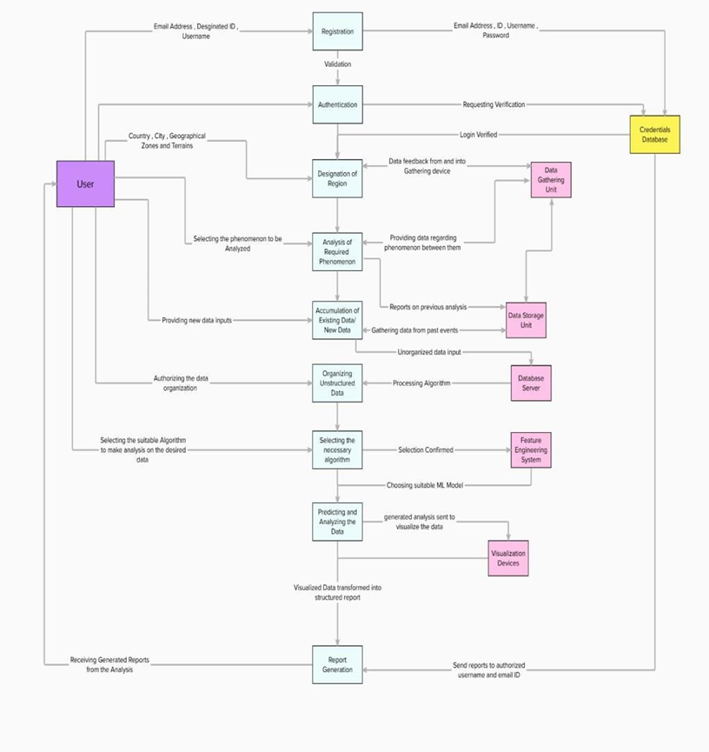

5.2 Solution & Technical Architecture:

**Solution Architecture:**

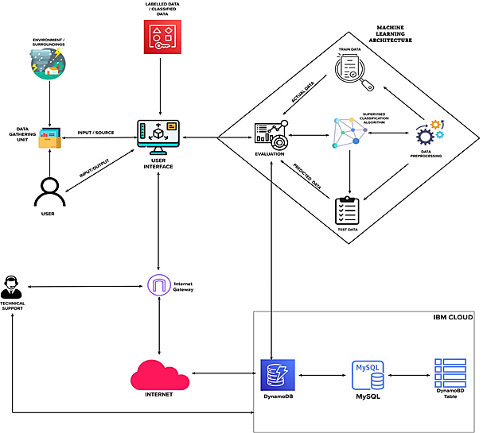

**Technical Architecture:**

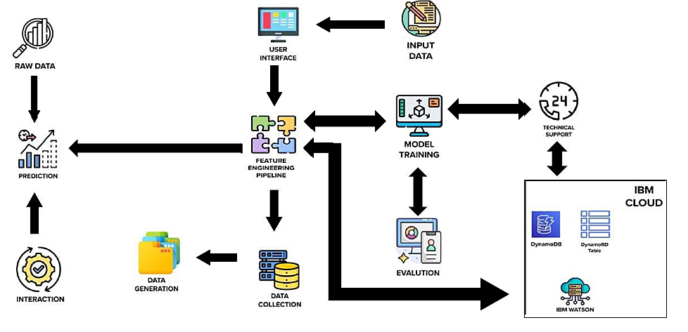

**Table-1: Components & Technologies:**

|  |  |  |  |
| --- | --- | --- | --- |
| **S. No** | **Component** | **Description** | **Technology** |
| 1. | User Interface | User interacts with application for the prediction of Any Natural disaster which will happen in future minutes. | HTML, CSS, JavaScript, Django, Python. |
| 2. | Feature Engineering Pipeline | Algorithms can't make sense of raw data. We have to select, transform, combine, and otherwise prepare our data so the algorithm can find useful patterns. | Image processing, pattern extraction, etc. |
| 3. | Model Training kit | It learns patterns from the data. Then they use these patterns to perform particular tasks. | Multiclass Classification Model, Regression Model, etc. |
| 4. | Prediction unit | This function is used to predict outcomes from the new trained data to perform new tasks and solve  new problems. | Decision trees, Regression, Neural networks. |
| 5. | Evaluation system | It monitors that how Algorithm performs on data as well as during training. | Chi-Square, Confusion Matrix, etc. |
| 6. | Interactive services | To interact with our model and give it problems to  solve. Usually this takes the form of an API, a user interface, or a command-line interface. | Application programming interface, etc. |
| 7. | Data collection unit | Data is only useful if it’s accessible, so it needs to  be stored ideally in a consistent structure and conveniently in one place. | IBM Cloud, SQL Server. |
| 8. | Data generation system | Every machine learning application lives off data. That data has to come from somewhere. Usually,  it’s generated by one of your core business functions. | Synthetic data generation. |
| 9. | Database management system | An organized collection of data stored in database, so that it can be easily accessed and managed. | MySQL, Dynamo DB etc. |
| 10. | IBM Cloud services | Processed data stored in cloud service which can be access by the admin anywhere over the internet. | IBM Cloud etc. |

**Table-2: Application Characteristics:**

|  |  |  |  |
| --- | --- | --- | --- |
| **S. No** | **Characteristics** | **Description** | **Technology** |
| 1. | Open-Source Frameworks | An open source framework is a template for software development that is designed by a social network of software developers. These frameworks are free for public use and provide the foundation for building a software application. | Karas, Tensor Flow. |
| 2. | Authentication | This keeps our models secure and makes sure only those who have permission can use them. | Encryption and Decryption (OTP). |
| 3. | Application interface | User uses mobile application and web application to interact with model | Android and Web Development |
| 4. | Availability (both Online and Offlinework) | Its include both online and offline work. As good internet connection is need for online work to explore the software perfectly. Offline work includes the saved data to explore for later time. | Caching, backend server. |
| 5. | Regular Updates | The truly excellent software product needs a continuous process of improvements and updates. Maintain your server and make sure that your content is always up-to-date. Regularly update an app and enrich it with new features. | Waterfall Approach  Incremental Approach  Spiral Approach |
| 6. | Personalization | Software has features like flexible fonts, backgrounds, settings, colour themes, etc. which make a software interface looks good and functional. | HubSpot  Proof |

5.3 User Stories:

|  |  |  |  |  |  |  |  |
| --- | --- | --- | --- | --- | --- | --- | --- |
|  |  | **Functional** | **User** | **User Story/ Task** | **Acceptance** | **Priority** | **Release** |
| **User** | | **Requirement** | **Story** |  | **criteria** |  |  |
| **Type** | | **(Epic)** | **Number** |  |  |  |  |
|  | |  | **(USN)** |  |  |  |  |
| End user  (Customer) | | Registration | USN - 1 | As a user, I am able to register with the product using my valid email address | I should be able to register with my account credentials | High | Sprint - 1 |
|  | |  | USN - 2 | As a user, I am able to | It should ensure | High | Sprint - 1 |
| End User  (Customer) | | Authentication |  | login into the system  with my credentials | smooth login  capabilities without delay |  |  |
|  | |  | USN - 3 | I can select the region | I must be able to | High | Sprint - 1 |
| End User  (Customer) | | Designation of Region |  | of interest to be  monitored and analyzed | choose certain  specific places without error |  |  |
| End User  (Customer) | | Analysis of Required  Phenomenon | USN - 4 | I am able to monitor certain factors that  influence the actions of the phenomenon | It should consider and monitor most of the factors involved in the  action | High | Sprint - 2 |
|  | |  |  |  |  |  |  |

|  |  |  |  |  |  |  |
| --- | --- | --- | --- | --- | --- | --- |
|  |  | USN - 5 | I am able to gather | It should allow the | Medium | Sprint - 2 |
| End User  (Customer) | Accumulation  of required |  | data regarding past  events and a detailed | storage of data of  past events for |  |  |
| Data |  | report on past analysis | certain extent |  |  |
| End User  (Customer) | Organizing Unstructured | USN - 6 | I am able to organize and restructure the | It should ensure easy and efficient | Low | Sprint - 3 |
|  | data |  | raw data into refined | processing |  |  |
|  |  |  | data | methods |  |  |
| End User  (Customer) | Algorithm selection | USN - 7 | I am able to choose the required algorithm | It must provide various options for | High | Sprint - 2 |
|  |  |  | for a specific analysis | the algorithm to be |  |  |
|  |  |  |  | used |  |  |
| End User  (Customer) | Prediction and analysis of data | USN - 8 | I am able to easily predict and visualize the data | It should allow easy to use prediction and visualization techniques | High | Sprint - 3 |
| End User  (Customer) | Report generation | USN - 9 | I am able to generate a clear and detailed | Report generation must be fast and | Medium | Sprint - 4 |
|  |  |  | report on the analysis | efficient and should |  |  |
|  |  |  |  | not be complex |  |  |

6. PROJECT PLANNING & SCHEDULING:

6.1 Sprint Planning and Estimation:

|  |  |  |  |  |  |  |
| --- | --- | --- | --- | --- | --- | --- |
| **Sprint** | **Functional**  **Requirement (Epic)** | **User Story**  **Number** | **User Story/ Task** | **Story**  **Points** | **Priority** | **Team Members** |
| Sprint-1 | Data Collection | USN-1 | As a user, I can collect the dataset from different images of cyclone. | 12 | Medium | V.Aravindh |
| Sprint-1 | Data Pre-processing | USN-2 | As a user, I can loathe dataset, scaling and split data into train and test. | 8 | High | S.Manoj |
| Sprint-2 | Model Building | USN-3 | As a user, I will get an application with ML model which provides high accuracy of images of cyclone. | 12 | High | M.Jothiraj    M.Jothiraj |

|  |  |  |  |  |  |  |
| --- | --- | --- | --- | --- | --- | --- |
| Sprint-2 | Train & test & Save model | USN-4 | As a user, let us train our model with our image dataset. | 8 | Medium | S.Manikandan |
| Sprint-3 | Building UI Application  HTML Page | USN-5 | As a user, I will upload the cycloneimage to the application by clicking an uploadbutton. | 10 | High | S.Manoj |
| Sprint-3 | Python Page | USN-6 | As a user, I can know the details of the fundamental usage of the application. | 10 | High | V.Aravindh |
| Sprint-4 | Train the model on IBM | USN-7 | As a user,I train the model and integrate them on IBM. | 7 | Medium | S.Manikandan |
| Sprint-4 | Cloud Deployment | USN-8 | As a user, I can access the web application and make the use of the product from anywhere. | 13 | High | M.Jothiraj |

6.2 Sprint Delivery Schedule:

|  |  |  |  |  |  |
| --- | --- | --- | --- | --- | --- |
| **Sprint** | **Total Story Points** | **Duration** | **Sprint Start Date** | **Sprint End Date(Planned)** | **Story PointsCompleted (as on planned**  **End Date)** |
| Sprint 1 | 20 | 6 Days | 24 Oct 2022 | 29 Oct 2022 | 20 |
| Sprint 2 | 20 | 6 Days | 31 Oct2022 | 05 Nov 2022 | 20 |
| Sprint 3 | 20 | 6 Days | 07 Nov 2022 | 12 Nov 2022 | 20 |
| Sprint 4 | 20 | 6 Days | 14 Nov 2022 | 19 Nov 2022 | 20 |

6.3 Reports Form Jair

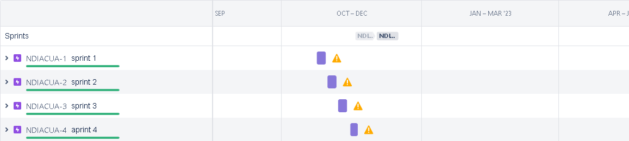

7. CODING & SOLUTIONING:

7.1 Feature 1:

A convolution al neural network is a class of [artificial neural networks.](https://en.wikipedia.org/wiki/Artificial_neural_network) It is a Deep Learning algorithm that can take in an input image, assign importance to various objects in the image and be able to differentiate one from the other. The pre-processing required in a ConvNet is much lower as compared to other classification algorithms.

The advantage of CNNs is to provide an efficient dense network which performs the prediction or identification efficiently.

7.2 Feature 2:

We developed a multilayered deep convolution al neural network model that classifies the natural disaster and tells the intensity of disaster of natural The model uses an integrated webcam to capture the video frame and the video frame is compared with the Pre-trained model and the type of disaster is identified and showcased on the OpenCV window. A multi layer neural network with appropriate weights has been shown **to be able to approximate any input-output function making it an attractive tool for modeling and forecasting**.

8. TESTING:

8.1 TestCases:

**home.html:**

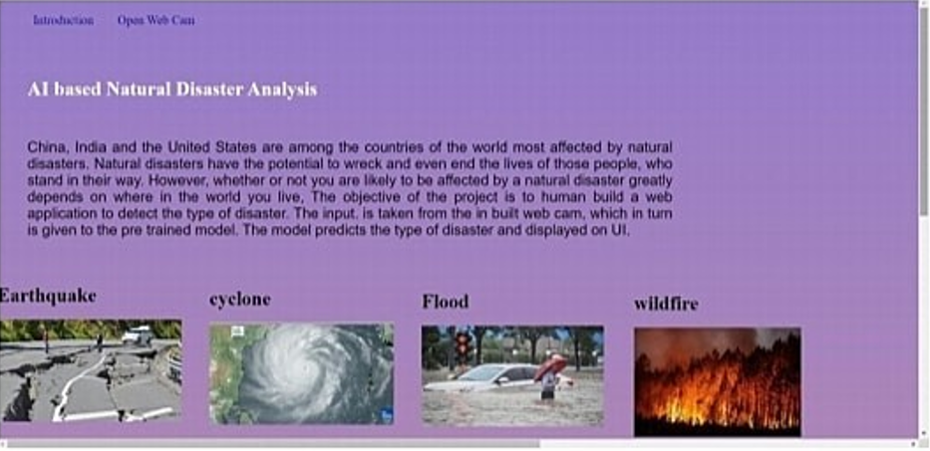

**Intro.html:**

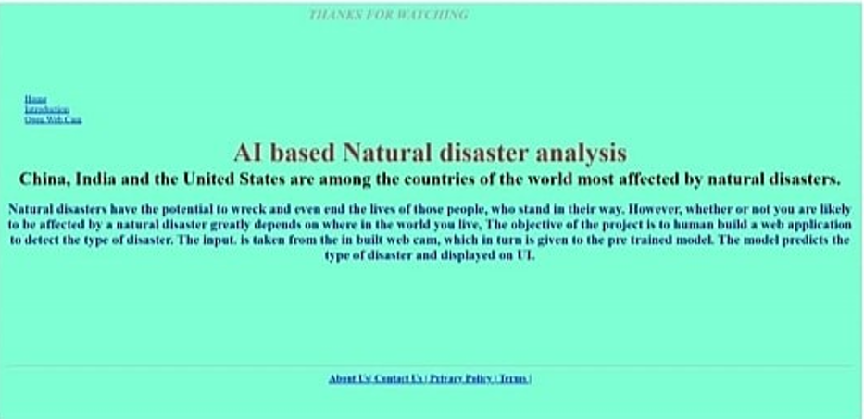

**Run.html:**

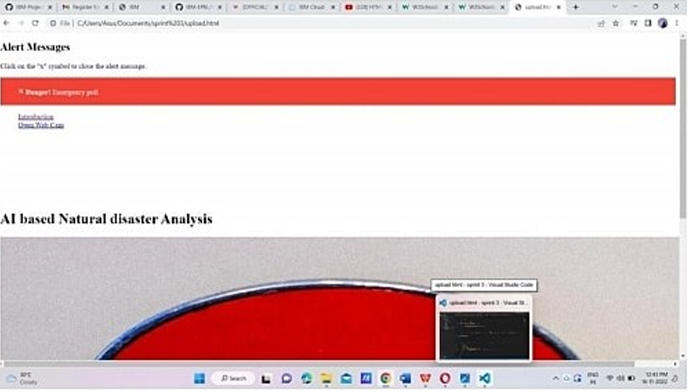

8.2 User Acceptance Testing:

This document serves as a quick reference for the Deep Learning Fund us Image Analysis for Early Detection of DiabeticRetinopathy project's test coverage and open issues as of the project's release for user acceptance testing.

**Defect Analysis:**

This shows how many bugs were fixed or closed at each severity level and how they were fixed.

|  |  |  |  |  |  |
| --- | --- | --- | --- | --- | --- |
| Resolution | Severity 1 | Severity 2 | Severity 3 | Severity 4 | Subtotal |
| By Design | 4 | 5 | 2 | 3 | 14 |
| Duplicate | 1 | 0 | 3 | 1 | 5 |
| External | 2 | 3 | 0 | 1 | 6 |
| Fixed | 9 | 2 | 4 | 15 | 30 |
| NotReproduced | 0 | 0 | 1 | 0 | 1 |
| Skipped | 1 | 0 | 1 | 1 | 3 |
| Won't Fix | 0 | 5 | 2 | 1 | 8 |
| Totals | 17 | 14 | 13 | 22 | 64 |

**Test-Case Analysis****:**

This report shows the number of test cases that have passed, failed,and untested.

|  |  |  |  |  |
| --- | --- | --- | --- | --- |
| Section | Total Cases | Not Tested | Fail | Pass |
| Print Engine | 9 | 0 | 0 | 9 |
| Client Application | 40 | 0 | 0 | 40 |
| Security | 3 | 0 | 0 | 3 |
| Out-source Shipping | 3 | 0 | 0 | 3 |
| Exception Reporting | 8 | 0 | 0 | 8 |
| Final ReportOutput | 4 | 0 | 0 | 4 |
| Version Control | 2 | 0 | 0 | 2 |

9. RESULTS:

9.1 Performance Metrics:

|  |  |  |
| --- | --- | --- |
| **S.No.** | **Parameter** | **Values(Percentage)** |
| 1. | Model Summary | **-**96% |
| 2. | Accuracy | Training Accuracy - 96.5%    Validation Accuracy -92.3% |
| 3. | Confidence Score (Only Yolo Projects) | Class Detected - Nil    Confidence Score- Nil |

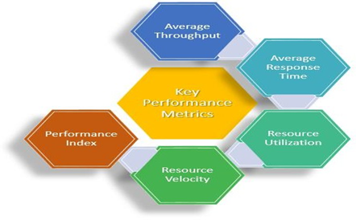

Our Project marks the successive performance by implementing in order to be cost effective and more reliable to use and to predict the future from the natural disaster that we are ahead of. The successive way includes the objectives, activities and the approaches for the project. It mainly includes the trained dataset which gives an excessive measure of success which helps to overcome the future from this natural disaster.

10. ADVANTAGES AND DISADVANTAGES:

**ADVANTAGES:**

1. The use of AI to forecast natural disasters would save millions of lives. Furthermore, the information evaluated by AI-powered systems can aid in understanding the scale and patterns of natural catastrophes such as floods, earthquakes, and tsunamis, which would aid in improved infrastructure development in disaster-prone areas.

2. Disaster management plays an integral role in keeping communities safe. It involves coordinating the resources, such as pollution control systems, and responsibilities, such as following best practice policies, needed to prevent, prepare for, respond to, and recover from emergencies

**DISADVANTAGES:**

1. A forest fire is a natural disaster that cannot be forecasted.

2. Sometimes the prediction may fail and result in huge loss.

11. CONCLUSION:

Natural disasters inflict severe damage on almost the entire spectrum of social and natural habitats, ranging from housing and shelter, water, food, health, sanitation, and waste management to information and communication networks, supply of power and energy, and transportation infrastructure. The major challenges faced in all disasters include pre-disaster early warning infrastructure; the supply of food and clean drinking water; health and sanitation; information and communication; power and energy for lighting and cooking; waste collection and disposal, including rapid disposal of dead bodies of humans and animals; disaster-proof housing and shelter; emergency and post-disaster shelters; rescue and relief operations; and transport infrastructure. Though it is not possible to prevent most of the disasters, still their effects can be alleviated or mitigated in magnitude by anticipated preparedness. Advanced disaster management technology could provide a critical support system for disaster management authorities at times of disaster-related crises. Such a technology also provides important inputs for any disaster management plan of action in modern times. Communities and individuals have to be educated on pre-disaster planning and preparedness. Awareness must be created amongst masses, for which first-aid training at grass roots level is essential. There should be a National Disaster Plan that defines the tasks of the communities and local health personnel.

For the evaluation of the model ROC and 30% landslide point’s residual was used. The results showed that the accuracy of the model was estimated by ANFIS in the study area of 77.48%(good accuracy); this data-mining method depends on the number of pairs of training, experimental and fuzzy data used in the research, and, in particular, by increasing the number of fuzzy rules of the process, more accurate simulation can be provided. So far, different methods have been proposed for landslide susceptibility donation. The accuracy or the error of each of these methods, as well as the use and comparison of each of these methods, requires knowledge of the foundations on which the methods are based. So far, different approaches to landslide susceptibility donation have been proposed, but what is certain is that all these methods can provide accurate results with minimal data and costs and at measure levels. Combining these models with GIS and [RS](https://www.sciencedirect.com/topics/earth-and-planetary-sciences/remote-sensing) systems not only increases the accuracy of dealing with complex issues and uncertainties, but also leads to the emergence and development of new theories and methods in a variety of issues.

12. FUTURE SCOPE:

The term “Natural Disaster” encompasses the complete realm of disaster-related activities. Traditionally people tend to think of disaster management only in terms of the post-disaster actions taken by relief and reconstruction officials; yet disaster management covers a much broader scope,and many modern disaster managers may find themselves far more involved in pre-disaster activities than in post-disaster response. Those are:

* The refugee field of disaster management is highly specialized and requires not only many development skills but also a broader awareness of political, legal, and humanitarian issues
* DM aims and objectives, elements,Natural/man-made Disasters, Victims,Relief Systems.
* Phases of DisasterResponse/Relief Operations, Government’s Role

To Safeguard and make available vital materials, supplies and equipment to ensure the safety and recovery of records from predictable disasters.To reduce the risk of disasters caused by human error, deliberate destruction, and building or equipment failures. Be better prepared to recover from a major natural catastrophe.

In this project we help to build preparedness for threats and hazards by providing a low-risk, cost- effective environment to: Test and validate plans, policies, procedures and capabilities. Identify resource requirements, capability gaps, strengths, areas for improvement, and potential best practices. Disaster management aims to reduce, or avoid, the potential losses from hazards, assure prompt and appropriate assistance to victims of disaster, and achieve rapid and effective recovery. Disaster Risk Management includes the sum total of all activities, program mes and measures which can be taken up before,during and after a disaster with the purpose to avoid a disaster, reduce its impact or recover from its losses.

13. APPENDIX:

SOURCE CODE

**home.html:**

1. <!DOCTYPE html>
3. <html lang="en">
4. <head>
5. <title>Home Page</title>
6. <meta charset="utf-8">
7. <meta name="viewport" content="width=device-width, initial-scale=1">
8. <link rel="stylesheet" href="https://maxcdn.bootstrapcdn.com/bootstrap/3.4.1/css/bootstrap.min.css">
9. <link href="https://fonts.googleapis.com/css?family=Montserrat" rel="stylesheet" type="text/css">
10. <link href="https://fonts.googleapis.com/css?family=Lato" rel="stylesheet" type="text/css">
11. <script src="https://ajax.googleapis.com/ajax/libs/jquery/3.5.1/jquery.min.js"></script>
12. <script src="https://maxcdn.bootstrapcdn.com/bootstrap/3.4.1/js/bootstrap.min.js"></script>

15. <style> body {
16. font: 400 15px Lato, sans-serif; line-height: 1.8;
17. color: #818181;
18. }
19. h2 {
20. font-size: 24px;
21. text-transform: uppercase; color: #303030;
22. font-weight: 600; margin-bottom: 30px;
23. }
24. h4 {
25. font-size: 19px;
26. line-height: 1.375em; color: #303030;
27. font-weight: 400; margin-bottom: 30px;
28. }
29. .jumbotron {
30. background-color: #f4511e; color: #fff;
32. font-family: Montserrat, sans-serif;
33. }
34. .container-fluid { padding: 60px 50px;
35. }
36. .bg-grey {
37. background-color: #f6f6f6;
38. }
39. .logo-small { color: #f4511e; font-size: 50px;
40. }
41. .logo {
42. color: #f4511e; font-size: 200px;
43. }
44. .thumbnail {
45. padding: 0 0 15px 0; border: none;
46. border-radius: 0;
47. }
48. .thumbnail i mg { width: 100%;
49. height: 100%;
50. margin-bottom: 10px;
51. }
52. .carousel-control.right, .carousel-control.left { background-image: none;
53. color: #f4511e;
54. }
55. .carousel-indicators li { border-color: #f4511e;
56. }
57. .carousel-indicators li.active { background-color: #f4511e;
59. }
60. .item h4 {
61. font-size: 19px;
62. line-height: 1.375em; font-weight: 400; font-style: italic; margin: 70px 0;
63. }
64. .item span {
65. font-style: normal;
66. }
67. .panel {
68. border: 1px solid #f4511e; border-radius:0 !important; transition: box-shadow 0.5s;
69. }
70. .panel:hover {
71. box-shadow: 5px 0px 40px rgba(0,0,0, .2);
72. }
73. .panel-footer .btn:hover { border: 1px solid #f4511e;
74. background-color: #fff !important; color: #f4511e;
75. }
76. .panel-heading {
77. color: #fff !important;
78. background-color: #f4511e !important; padding: 25px;
79. border-bottom: 1px solid transparent; border-top-left-radius: 0px;
80. border-top-right-radius: 0px; border-bottom-left-radius: 0px; border-bottom-right-radius: 0px;
81. }
82. .panel-footer {
84. background-color: white !important;
85. }
86. .panel-footer h3 { font-size: 32px;
87. }
88. .panel-footer h4 { color: #aaa;
89. font-size: 14px;
90. }
91. .panel-footer .btn { margin: 15px 0;
92. background-color: #f4511e; color: #fff;
93. }
94. .navbar {
95. margin-bottom: 0; background-color: #0059ff; z-index: 9999;
96. border: 0;
97. font-size: 12px !important;
98. line-height: 1.42857143 !important; letter-spacing: 4px;
99. border-radius: 0;
100. font-family: Montserrat, sans-serif;
101. }
102. .navbar li a, .navbar .navbar-brand { color: #fff !important;
103. }
104. .navbar-n av li a:hover, .navbar-n av li.active a { color: #f4511e !important;
105. background-color: #fff !important;
106. }
107. .navbar-default .navbar-toggle { border-color: transparent; color: #fff !important;
109. }
110. footer .glyphicon { font-size: 20px; margin-bottom: 20px; color: #f4511e;
111. }
112. .slideanim {visibility:hidden;}
113. .slide {
114. animation-name: slide;
115. -webkit-animation-name: slide; animation-duration: 1s;
116. -webkit-animation-duration: 1s; visibility: visible;
117. }
118. @keyframes slide { 0% {
119. opacity: 0;
120. transform: translateY(70%);
121. } 100% {
122. opacity: 1;
123. transform: translateY(0%);
124. }
125. }
126. @-webkit-key frames slide { 0% {
127. opacity: 0;
128. -webkit-transform: translateY(70%);
129. } 100% {
130. opacity: 1;
131. -webkit-transform: translateY(0%);
132. }
133. }
134. @media screen and (max-width: 768px) {
136. .col-sm-4 {
137. text-align: center; margin: 25px 0;
138. }
139. .btn-lg { width: 100%;
140. margin-bottom: 35px;
141. }
142. }
143. @media screen and (max-width: 480px) {
144. .logo {
145. font-size: 150px;
146. }
147. }

150. .container {
151. padding: 16px;
152. max-width: max-content;
153. }

156. .container {
157. max-width: 1376px; margin: auto;
158. padding: 2rem 1.5rem;
159. }

162. .cards {
163. display: flex; flex-wrap: wrap;
164. align-items: center; justify-content: center;
165. }
167. .card {
168. cursor: pointer;
170. background-color: transparent; height: 300px;
171. perspective: 1000px; margin: 1rem;
172. align-items: center; justify-content: center;
173. }

176. .card h3 {
177. border-bottom: 1px #fff solid; padding-bottom: 10px; margin-bottom: 10px;
178. text-align: center; font-size: 1.6rem; word-spacing: 3px;
179. }

182. .card p{ opacity: 0.75;
183. font-size: 0.8rem; line-height: 1.4;
184. }
186. .card i mg { width: 360px; height: 300px; object-fit: cover;
187. border-radius: 3px;
188. }

191. .card-inner { position: relative; width: 360px; height: 100%;
192. transition: transform 0.9s;
194. transform-style: preserve-3d;
195. }

198. .card:hover .card-inner { transform: rotateY(180deg);
199. }

202. .card-front,
203. .card-back { position: absolute; width: 360px; height: 100%;
204. -webkit-back face-visibility: hidden; back face-visibility: hidden;
205. }

208. .card-back {
209. background-color: #222; color: #fff;
210. padding: 1.5rem;
211. transform: rotateY(180deg);
212. }
213. .text-block { position: absolute; bottom: 20px; right: 20px;
214. background-color: black; color: white;
216. padding-left: 20px; padding-right: 20px;
217. }
218. .features-section img { display: none;
219. }

222. .testimonials-section {
223. background: var(--primary-color); color: white;
224. }

227. .testimonials-section li { background: #0059ff; text-align: center; width: 80%;
228. border-radius: 1em;
229. }
231. .testimonials-section li i mg { width: 6em;
232. height: 6em;
233. border: 3px solid #ffffff; border-radius: 50%; margin-top: -2.5em;
234. }

237. ul {
238. list-style-type: none; margin: 0;
239. padding: 0;
240. }


244. ul.features-list { margin: 0;
245. padding-left: .1em;
246. }
248. ul.features-list li { font-size: 1.1em;
250. margin-bottom: 1em; margin-left: 2em; position: relative;
251. }

254. ul.features-list li:before { content: '';
255. left: -2em; position: absolute; width: 20px; height: 20px;
256. background-image: url("#"); background-size: contain; margin-right: .5em;
257. }

260. .features-section img { display: none;
261. }
262. </style>
263. </head>
264. <body>
265. <div class="card text-center">
266. <div class="card-header">
267. <ul class="nav nav-tabs card-header-tabs">
268. <li class="nav-item">
269. <a class="nav-link active" aria-current="true" href="home.html" style="font-size: 24px;">Home</a>
270. </li>
271. <li class="nav-item">
272. <a class="nav-link" href="intro.html" style="font-size: 24px;">Introduction</a>
273. </li>
274. <li class="nav-item">
275. <a class="nav-link" href="upload.html" style="font-size: 24px;">Upload</a>
276. </li>
278. </ul>
279. <h3 style="float: right;">AI based Natural Disaster Analysis</h3>
280. </div>
281. <div class="container-fluid">
282. <div class="container">

285. <div class="cards">
287. <div class="card">
288. <div class="card-inner">
289. <div class="card-front">
290. <img src="https://images.unsplash.com/photo-1454789476662- 53eb23ba5907?ixid=MXwxMjA3fDB8MHxwaG90by1wYWdlfHx8fGVufDB8fHw%3D&ixlib=rb- 1.2.1&auto=format&fit=crop&w=689&q=80"
291. alt="">
292. <div class="text-block">
293. <h1>Cyclone</h1>
294. <h3>violent winds, torrential rain, high waves and, very destructive storm</h3>
295. </div>







304. near

307. </div>
308. <div class="card-back">
309. <h3>Cyclone</h3>
310. <h3>The effects of tropical cyclones include heavy rain, strong wind, large storm surges
312. landfall, and tornadoes. The destruction from a tropical cyclone, such as a hurricane or tropical storm, depends mainly on its intensity, its size, and its location.</h3>
313. </div>
314. </div>
315. </div>
317. <div class="container">

320. <div class="cards">
322. <div class="card">
323. <div class="card-inner">
325. <div class="card-front">
326. <img src="https://images.unsplash.com/photo-1603869311144- 66b03d340b32?ixid=MXwxMjA3fDB8MHxzZWFyY2h8M3x8ZWFydGhxdWFrZXxlbnwwfHwwfA%3 D%3D&ixlib=rb-1.2.1&auto=format&fit=crop&w=500&q=60"
327. alt="">
328. <div class="text-block">
329. <h1>Earth Quake</h1>
330. <h3>Sudden release of stored energy in the Earth's crust that creates seismic
332. waves.








342. fault. shake.

345. </h3>
346. </div>

349. </div>
350. <div class="card-back">
351. <h3>Earth Quake</h3>
352. <h3>Earthquakes are usually caused when rock underground suddenly breaks along a This sudden release of energy causes the seismic waves that make the ground
353. ... During the earthquake and afterward, the plates or blocks of rock start moving, and they continue to move until they get stuck again.</h3>
354. </div>
355. </div>
356. </div>
358. <div class="container">
359. <div class="cards">
360. <div class="card">
361. <div class="card-inner">
362. <div class="card-front">
363. <img src="https://images.unsplash.com/photo-1547683905- f686c993aae5?ixid=MXwxMjA3fDB8MHxzZWFyY2h8MXx8Zmxvb2R8ZW58MHx8MHw%3D&ixlib
364. =rb-1.2.1&auto=format&fit=crop&w=500&q=60"
365. alt="">
366. <div class="text-block">
367. <h1>Flood</h1>
368. <h3>A flood is an overflow of water on normally dry ground</h3>
369. </div>







378. by

381. crossings
383. </div>
384. <div class="card-back">
385. <h3>Flood</h3>
386. <h3>During heavy rain, the storm drains can become overwhelmed or plugged
388. debris and flood the roads and buildings nearby. Low spots, such as underpasses, underground parking garages, basements, and low water
390. can become death traps. Areas near rivers are at risk from floods.</h3>
391. </div>
392. </div>
393. </div>
395. <div class="container">

398. <div class="cards">
400. <div class="card">
401. <div class="card-inner">
402. <div class="card-front">
403. <img src="https://images.unsplash.com/photo-1473260079709- 83c808703435?ixid=MXwxMjA3fDB8MHxzZWFyY2h8NHx8d2lsZGZpcmV8ZW58MHx8MHw%3D &ixlib=rb-1.2.1&auto=format&fit=crop&w=500&q=60"
404. alt="">
405. <div class="text-block">
406. <h1>WildFire</h1>
407. <h3>Uncontrolled fire in a forest, grassland, brushland</h3>
408. </div>

411. </div>
412. <div class="card-back">
413. <h3>Wildfire</h3>
414. <h3>Wildfires can be caused by an accumulation of dead matter (leaves, twigs, and trees) that can create enough heat in some instances to combust spontaneously and ignite the surrounding area. Lightning strikes the earth over 100,000 times a day. 10 to 20% of these
415. lightning strikes can cause fire.</h3>
416. </div>
417. </div>
418. </div>
419. </div>

**intro.html:**

1. <!DOCTYPE html>
2. <html lang="en">
3. <head>
4. <meta charset="UTF-8">
5. <meta http-equiv="X-UA-Compatible" content="IE=edge">
6. <meta name="viewport" content="width=device-width, initial-scale=1.0">
7. <link href="https://cdn.jsdelivr.net/npm/bootstrap@5.2.2/dist/css/bootstrap.min.css"
8. rel="stylesheet" integrity="sha384- Zenh87qX5JnK2Jl0vWa8Ck2rdkQ2Bzep5IDxbcnCeuOxjzrPF/et3URy9Bv1WTRi" crossorigin="anonymous">
9. <title>Document</title>
10. </head>
11. <body>
12. <div class="card text-center">
13. <div class="card-header">
14. <ul class="nav nav-tabs card-header-tabs">
15. <li class="nav-item">
16. <a class="nav-link" aria-current="true" href="home.html" style="font-size: 24px;">Home</a>
17. </li>
18. <li class="nav-item">
19. <a class="nav-link active" href="intro.html" style="font-size: 24px;">Introduction</a></li>
20. <li class="nav-item">
21. <a class="nav-link" href="upload.html" style="font-size: 24px;">Upload</a>
22. </li>
23. </ul>
24. <h3 style="float: right;">AI based Natural Disaster Analysis</h3>
25. </div>
27. </div>
28. <h2 style="padding: 50px; margin: 50px; word-spacing: 15px; text-align: center ;line-height: 1.6;">
29. China, India and the United States are among the countries in the world most
30. affected by natural disasters. Natural disasters have the potential to wreck and even end the lives of those people, who stand in their way. <br><br> However, whether or not you are likely to be
31. affected by a natural disaster dramatically depends on where in the world you live, The objectiveness project is to human build a web application to detect the type of disaster. The input
32. is taken from the in-built webcam, which in turn is given to the pre-trained model. The model predicts the type of disaster and displayed on UI. </h2>
33. </body>
34. </html>

**run.html**

1. <<!DOCTYPE html>
2. <html lang="en">
3. <head>
4. <meta charset="UTF-8">
5. <meta http-equiv="X-UA-Compatible" content="IE=edge">
6. <meta name="viewport" content="width=device-width, initial-scale=1.0">
7. <link href="https://cdn.jsdelivr.net/npm/bootstrap@5.2.2/dist/css/bootstrap.min.css"
8. rel="stylesheet" integrity="sha384- Zenh87qX5JnK2Jl0vWa8Ck2rdkQ2Bzep5IDxbcnCeuOxjzrPF/et3URy9Bv1WTRi" crossorigin="anonymous">
9. <title>Document</title>
10. </head>
11. <body>
12. <div class="card text-center">
13. <div class="card-header">
14. <ul class="nav nav-tabs card-header-tabs">
15. <li class="nav-item">
16. <a class="nav-link" aria-current="true" href="home.html" style="font-size: 24px;">Home</a>
17. </li>
18. <li class="nav-item">
20. <a class="nav-link" href="intro.html" style="font-size: 24px;">Introduction</a>
21. </li>
22. <li class="nav-item">
23. <a class="nav-link active" href="upload.html" style="font-size: 24px;">Upload</a>
24. </li>
25. </ul>
26. <h3 style="float: right;">AI based Natural Disaster Analysis</h3>
27. </div>
28. </div>
29. <form action = "uploader.html" method = "POST" enctype = "multipart/form-data">
30. <input type = "file" name = "filename" />
31. <input type = "submit" value="Submit"/>
32. </form>
33. <script src="https://cdn.jsdelivr.net/npm/@popperjs/core@2.11.6/dist/umd/popper.min.js"
34. integrity="sha384-
35. oBqDVmMz9ATKxIep9tiCxS/Z9fNfEXiDAYTujMAeBAsjFuCZSmKbSSUnQlmh/jp3" crossorigin="anonymous"></script>
36. <script src="https://cdn.jsdelivr.net/npm/bootstrap@5.2.2/dist/js/bootstrap.min.js" integrity="sha384-
37. IDwe1+LCz02ROU9k972gdyvl+AESN10+x7tBKgc9I5HFtuNz0wWnPclzo6p9vxnk"crossorigin="anony
38. mous"></script>
39. </body>
40. </html>

**App.py:**

1. from flask import Flask,render_template,request
2. import cv2
3. from tensorflow import keras
4. from tensorflow.keras import models
5. from tensorflow.keras.models import load_model
6. import numpy as np
7. import random
8. from time import time, sleep
9. import time
10. def ran(result):
11. if(result=='Cyclone'):
12. return 2
13. elif (result=='Earthquake'):
14. return 3
15. elif (result=='Flood'):
16. return 1
17. elif (result=='Wildfire'):
18. return 4
19. # from time import time, sleep
20. # import time
21. # result1=1
22. app = Flask(__name__,template_folder="Templates")
23. model=load_model("disaster.h5")
24. #print(model)
26. @app.route('/',methods=['GET'])
27. def index():
28. return render_template('home.html')
30. @app.route('/home',methods=['GET'])
31. def home():
32. return render_template('home.html')
34. @app.route('/intro',methods=['GET'])
35. def about():
36. return render_template('intro.html')
38. @app.route('/run',methods=['GET'])
39. def upload():
40. return render_template('run.html')
42. @app.route('/uploader',methods=['GET','POST'])
43. def predict():
44. # if request.method == "POST":
45. # f = request.files['filename'].stream
46. # f.save("videos/save.mp4")
47. # print("saved")

50. # Create a VideoCapture object and read from input file
51. # If the input is the camera, pass 0 instead of the video file name
52. cap = cv2.VideoCapture(0)
54. # Check if camera opened successfully
55. if (cap.isOpened()== False):
56. print("Error opening video stream or file")
57. # start = time.process_time()
58. # Read until video is completed
59. while(True):
60. # Capture frame-by-frame
61. ret, frame = cap.read()
62. if ret == True:
63. frame=cv2.flip(frame,1)
64. output = frame.copy()
65. frame = cv2.cvtColor(frame,cv2.COLOR_BGR2RGB)
66. frame = cv2.resize(frame,(64,64))
67. x=np.expand_dims(frame,axis=0)
68. result = np.argmax(model.predict(x),axis=1)
69. index=['Cyclone','Earthquake','Flood','Wildfire']
70. result = str(index[result[0]])
71. #print(result)
72. res=ran(result)
73. cv2.putText(output,"Intensity: {}".format(res),(10,120),cv2.FONT_HERSHEY_PLAIN,1,(0,25,255),1)
74. cv2.putText(output,"Disaster: {}".format(result),(10,100),cv2.FONT_HERSHEY_PLAIN,1,(0,25,255),1)
75. # Display the resulting frame
76. cv2.imshow('Frame',output)
77. # Press Q on keyboard to exit
78. if cv2.waitKey(1) & 0xFF == ord('q'):
79. break
81. # Break the loop
82. else:
83. break
84. # When everything done, release the video capture object
85. cap.release()
87. # Closes all the frames
88. cv2.destroyAllWindows()
89. return render_template('run.html')
90. # cap=cv2.VideoCapture(0)
91. # while(True):
92. # _,frame = cap.read()
93. # frame=cv2.flip(frame,1)
94. # while(True):
95. # (grabbed,frame) = cap.read()
96. # if not grabbed:
97. # break
98. # output = frame.copy()
99. # frame = cv2.cvtColor(frame,cv2.COLOR_BGR2RGB)
100. # frame = cv2.resize(frame,(64,64))
101. # x=np.expand_dims(frame,axis=0)
102. # result = np.argmax(model.predict(x),axis=1)
103. # index=['Cyclone','Earthquake','Flood','Wildfire']
104. # result = str(index[result[0]])
105. # #print(result)
106. # cv2.putText(output,"activity: {}".format(result),(10,120),cv2.FONT_HERSHEY_PLAIN,1,(0,25,255),1)
107. # cv2.imshow("Output",output)
108. # if cv2.waitKey(1000) | 0xFF==ord('q'):
109. # break
110. # print("[INFO]cleaning up...")
111. # cap.release()
112. # cv2.destroyAllWindows()
114. if __name__ == '__main__':
115. app.run(host='0.0.0.0',port=8000,debug=False)

**SCRIPT.JS:**

1. var btnLogin = document.getElementById('do-login');
2. var btnRun = document.getElementById('do-run');
3. var idLogin = document.getElementById('login');
4. var username = document.getElementById('username');
5. btnLogin.onclick = function(){
6. idLogin.innerHTML = '<p>Hi, </p><h1>' +username.value+ '</h1><p>We hope you are safe :)<br>This application aims to solve real life problem of disaster identification <br>along with its estimated intensity on a level of 1-5.<br>1 denotes low level intensity while 5 denotes the highest intensity level.The users are requested<br> to use the run button to upload good, clarity pictures to run our conventional network ... </p><a href="run.html" style="font-size: 24px;">Run</a>';
7. }
8. btnRun.onclick = function(){
9. idLogin.innerHTML = '<p>Hi, </p><h1>' +username.value+ '</h1><form action="/action_page.php"><input type="file" id="myFile" name="filename"><br><input type="Submit"></form>';
10. }

**Style.css:**

1. body {
2. background-color: #ffffff;
3. background-image: url(myImage.gif);
4. /* background-image:url_for('static', filename='myImage.gif'); */
5. background-repeat: no-repeat;
6. background-size: cover;
7. background-attachment: fixed;
8. background-position: center;
9. font-family: Assistant, sans-serif;
10. display: flex;
11. min-height: 90vh;
12. }
13. .login {
14. color: white;
15. background: #000000;
16. background: #000000;
17. background: #000000;
18. margin: auto;
19. box-shadow:
20. 0px 2px 10px rgba(0,0,0,0.2),
21. 0px 10px 20px rgba(0,0,0,0.3),
22. 0px 30px 60px 1px rgba(0,0,0,0.5);
23. border-radius: 8px;
24. padding: 50px;
25. }
26. .login .head {
27. display: flex;
28. align-items: center;
29. justify-content: center;
30. }
31. .login .head .company {
32. font-size: 2.2em;
33. }
34. .login .msg {
35. text-align: center;
36. }
37. .login .form input[type=text].text {
38. border: none;
39. background: none;
40. box-shadow: 0px 2px 0px 0px white;
41. width: 100%;
42. color: white;
43. font-size: 1em;
44. outline: none;
45. }
46. .login .form .text::placeholder {
47. color: #D3D3D3;
48. }
49. .login .form input[type=password].password {
50. border: none;
51. background: none;
52. box-shadow: 0px 2px 0px 0px white;
53. width: 100%;
54. color: white;
55. font-size: 1em;
56. outline: none;
57. margin-bottom: 20px;
58. margin-top: 20px;
59. }
60. .login .form .password::placeholder {
61. color: #D3D3D3;
62. }
63. .login .form .btn-login {
64. background: none;
65. text-decoration: none;
66. color: white;
67. box-shadow: 0px 0px 0px 2px white;
68. border-radius: 3px;
69. padding: 5px 2em;
70. transition: 0.5s;
71. }
72. .login .form .btn-login:hover {
73. background: white;
74. color: dimgray;
75. transition: 0.5s;
76. }
77. .login .forgot {
78. text-decoration: none;
79. color: white;
80. float: right;
81. }
82. footer {
83. position: absolute;
84. color: #136a8a;
85. bottom: 10px;
86. padding-left: 20px;
87. }
88. footer p {
89. display: inline;
90. }
91. footer a {
92. color: green;
93. text-decoration: none;
94. }
95. footer a:hover {
96. text-decoration: underline;
97. }
98. footer .heart {
99. color: #B22222;
100. font-size: 1.5em
101. }

GITHUB LINK:

<https://github.com/IBM-EPBL/IBM-Project-55022-1663578977>